Anon. A Farther brief and true narration of the late vvars risen in New-England occasioned by the quarrelsome disposition and perfidious carriage of the barbarous and savage Indian natives there : with an account of the fight, the 19th of December last, 1675. London : Printed by F.D. for M.K. ..., 1676.
———. A True account of the most considerable occurrences that have hapned in the warre between the English and the Indians in New-England from the fifth of May 1676, to the fourth of August last : as also of the successes it hath pleased God to give the English against them : as it hath been communicated by letters to a friend in London : the most exact account yet printed. London : Printed for Benjamin Billingsley ..., 1676.
———. News from New-England being a true and last account of the present bloody wars carried on betwixt the infidels, natives, and the English Christians and converted Indians of New-England, declaring the many dreadful battles fought betwixt them, as also the many towns and villages burnt by the merciless heathens and also the true number of all the Christians slain since the beginning of that war, as it was sent over by a factor of New-England to a merchant in London. London : Printed for J. Coniers, 1676.
———. Strange news from Virginia being a full and true account of the life and death of Nathanael Bacon, Esquire, who was the only cause and original of all the late troubles in that country : with a full relation of all the accidents which have happened in the late war there between the Christians and Indians. London : Printed for William Harris ..., 1677.
Eliot, John. A brief narrative of the progress of the Gospel amongst the Indians in New-England, in the year 1670 given in by the Reverend Mr. John Elliot, minister of the gospel there, in a letter by him directed to the right worshipfull the commissioners under His Majesties Great-Seal for propagation of the gospel amongst the poor blind natives in those United Colonies. London : Printed for John Allen ..., 1671.
———. Indian dialogues for their instruction in that great service of Christ, in calling home their country-men to the knowledge of God, and of themselves, and of Iesus Christ. Early English Books Online. Printed at Cambridge : [s.n.], 1671.
———. The logick primer some logical notions to initiate the Indians in the knowledge of the rule of reason and to know how to make use thereof : especially for the instruction of such as are teachers among them / composed by J.E. [Cambridge, Mass.] : Printed by M.J., 1672., 1672.
England and Wales. Articles of peace between the Most Serene ... Charles II ... and several Indian kings and queens, &c. concluded the 29th day of May, 1677. London : Printed by John Bill, Christopher Barker, Thomas Newcomb and Henry Hills ..., 1677.
Hubbard, William. A narrative of the troubles with the Indians in New-England, from the first planting thereof in the year 1607, to this present year 1677, but chiefly of the late troubles in the two last years, 1675 and 1676. To which is added a discourse about the warre with the Pequods in the year 1637. / By W. Hubbard ... Boston [Mass.] : Printed by John Foster, 1677.
———. The present state of New-England being a narrative of the troubles with the Indians in New-England, from the first planting thereof in the year 1607, to this present year 1677, but chiefly of the late troubles in the two last years 1675, and 1676 : to which is added a discourse about the war with the Pequods in the year 1637 / by W. Hubbard, minister of Ipswich. London : Printed for Tho. Parkhurst ..., 1677.
Hutchinson, Richard. The warr in New-England visibly ended King Philip that barbarous Indian now beheaded, and most of his bloudy adherents submitted to mercy, the rest far up into the countrey which hath given the inhabitants encouragement to prepare for their settlement : being a true and perfect account brought in by Caleb More master of a vessel newly arrived from Rhode Island : and published for general satisfaction. London : Printed by J.B. for Dorman Newman, 1677.
Mather, Increase. A brief history of the war with the Indians in New-England, from June 24, 1675 (when the first Englishman was murdered by the Indians) to August 12, 1676, when Philip, alias Metacomet, the principal author and beginner of the war, was slain wherein the grounds, beginning, and progress of the war is summarily expressed : together with a serious-exhortation to the inhabitants of that land / by Increase Mather.. London : Printed for Richard Chiswell, 1676.
N. S. A new and further narrative of the state of New-England being a continued account of the bloudy Indian-War, from March till August, 1676, giving a perfect relation of the several devastations, engagements, and transactions there : as also the great successes lately obtained against the barbarous Indians, the reducing of King Philip, and the killing of one of the queens, &c. : together with a catalogue of the losses in the whole sustaining on either side since the said war began, as near as can be collected. London : Printed by J.B. for Dorman Newman ..., 1676.

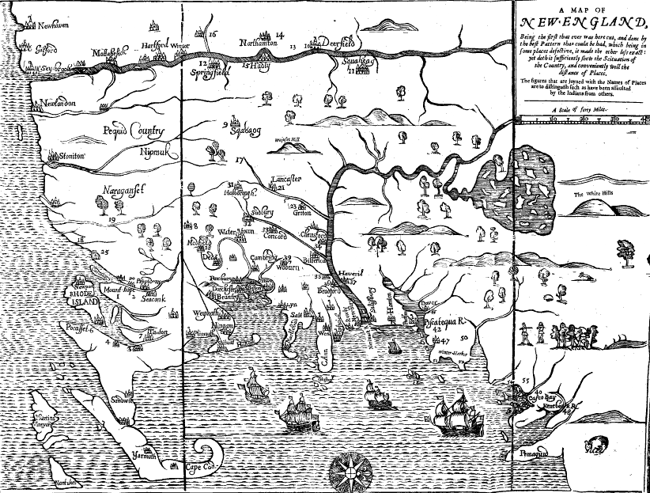

Hubbard, A narrative of the troubles with the Indians in New-England (1677), frontispiece

