Bookmark Managers

Browsers (Mozaic, Netscape, Mozilla, Internet Explorer)

Online Services – use “Folder Concept”

* BackFlip.com
* IKeepBookmarks.com
* MyHQ.com

Social Bookmarking - Online

* Tags Title Descriptions for Bookmarks and SHARING
* Delicious.com (del.icio.us )
  + A Yahoo Company – Yahoo MyWeb (old service)
* Diigo.com – option for Educator Accounts

**Delicious**

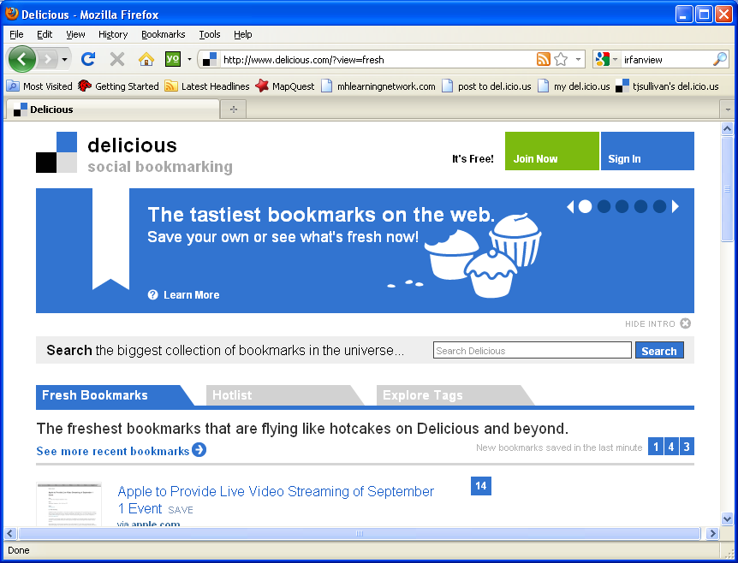

JOIN

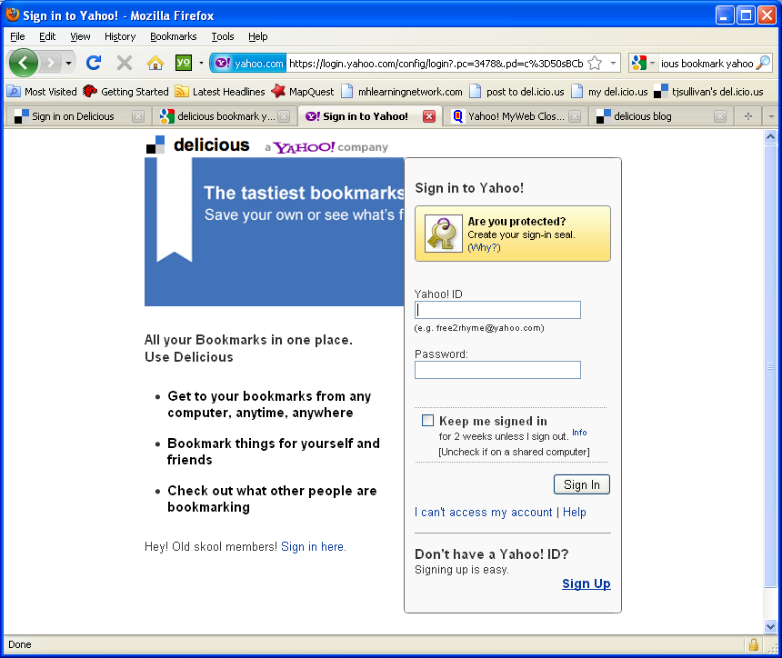

**Diigo**

