**I. Create or update a One Page RESUME for yourself.**

1. Include
   1. Career Goal(s)
   2. Picture of yourself, an EIU logo, and EIU Panther
   3. Education History
      1. Make it a TABLE with 3 columns
         1. Calendar Years
         2. Institution
         3. and Degrees or hours earned
      2. Be sure to include Eastern Illinois University and make it a LINK to www.eiu.edu
   4. Work History
   5. Professional Experiences
   6. List of Professional Organizations and Associations
   7. OPTIONAL – can use a WordArt Banner at the top but keep it professional
   8. Other as desired or needed

II. Mail Merge (We the People Live)

Write a letter home to parents explaining the class is going to participate in US Constitution Program on September 17th (Constitution Day). The program is online and from 11:00-11:45 Central Time which overlaps 10 minutes into lunch. Explain students will still have 30 minutes for lunch but it will be 10 minutes late that day. You may want to reference a couple facts off of <http://my.hmheducation.com/forms/QB7399> in your letter.

This needs to be a mail merge letter with statements somewhere in the letter

As part of our __grade_ class, your child ___name___ will participate

The US Constitution is important in ___town__ and is a model for the rest of the world

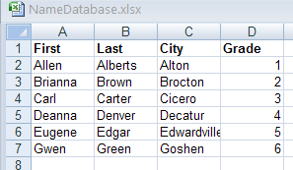Be sure to include the What, When, Where important facts in your letter. The final “master” document is what you will submit. This will be used to generate a set of letters from the instructors address database. It is important to use the same Field Names in your merge.